Sustainable Restoration of the Dalkeith Orangery
Feasibility Study

By: Stefinie Winter
Restoration of the Dalkeith Orangery
The Dalkeith Orangery is a conservatory that once housed citrus trees year round and provided shelter for outdoor parties, hosted by the Duchess of Buccleuch dating back to the early 1800’s. The orangery is located in Scotland on the Dalkeith Estate; with its rich history dating back to the fourteen hundreds, it housed many historical figures over time. Currently the estate is leased to the University of Wisconsin system, and is used year round as a study abroad program for college students. This paper will provide a brief historical background of the orangery and the estate. Additionally, focusing on some feasible ways to restore the orangery to a sustainable state. Lastly, there will be a discussion about the positive effects of a sustainably restored orangery on the students and the community in Dalkeith.
The origin of the orangery is a story engulfed in conceptualizing nature and societal status. Since it was considered symbolic for royalty to control nature, the Duchess and Duke of Buccleuch contracted William Burn as the designer to build the most extravagant Roman Doric orangery for the time period. Therefore, to reflect the time period of 1832 to 1834, Burn used materials such as white sandstone and wood for structural purposes. Then with cast-iron Burn developed the interior girders for support, and Arboath slabs as steps (Johnstone 1988). Despite the fact that the orangery began its origins in the 1800s and as expressed in Figure 1, continues its existence into the present day on the grounds of the Dalkeith Estate, the building like everything else in life changes with time.

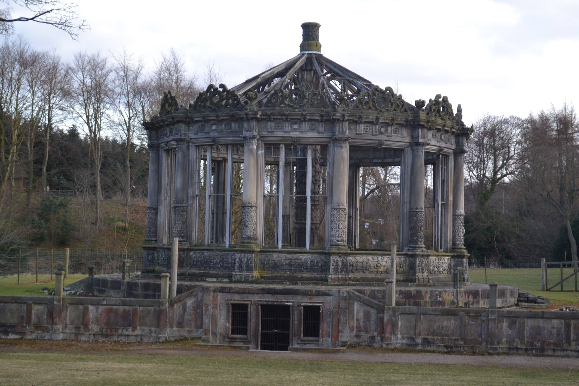

Figure 1: Dalkeith Orangery in its present state

The history of the orangery encompasses one part of the entire grounds at Dalkeith. Therefore, to hope for any renovation or usage of the orangery, an individual must be aware of the current attempts being made by the estate to promote sustainable development for the grounds as a whole. Unfortunately, after a conversation with Jo Krikhope, the Administrative Assistant at the Dalkeith Visitor Services, I discovered that although their sister estate, Bowhill is currently utilizing biomass; the Dalkeith estate is not currently promoting any sustainable development initiatives, but there is plenty of potential for sustainable development. Currently, the Dalkeith Orangery is not listed as a historical building, yet the historic codes should still be able to outline the process of the renovations. For many of these historic sites grants are available and the guidelines are not limited to just restoring the building to its original state, but rather include sustainable infrastructure. This is an unconventional method because normal historic buildings must be restored to its original state. However, the internal design of the Dalkeith Orangery allows for modernization through sustainability. But to create this eco-friendly atmosphere, the following proposed projects could be viable solutions to achieve this goal. These renovations include solar power, central boiler, food digestion, and utilizing geothermal as a heat source.
Evidently, solar panels are one of the most feasible options in the restoration of the orangery because they are known for their efficiency and cost effectiveness. Solar cells come in two different types, the first being photovoltaic, which converts sunlight into electricity. This type of cell comprises of three total subcategories and all of these require silicon in their production (National Energy Foundation 2008). The second type of solar cell and the more logical option for producing heat energy for the orangery is thermal. Thermal cells consume the suns energy and use it to heat water or air while then transferring the heat created to an interior space or storing it in a storage system to be utilized later (Energy and Environmental Affairs 2013). Thermal cells that would potentially be placed on top of the stable’s roof could be backed up by window box collectors in the orangery, which come in both active and passive forms. In active forms, a fan is utilized to heat the incoming air. Whereas in the passive forms the air is collected at the bottom and as it rises it heats adding approximately an additional thirty degrees. When the sun’s graceful presence isn’t peeking through the clouds of day or the darkness of night, the air remains in the interior of the building and is unable to flow back into the panel because of the barrier that was put in place. Alternative placement of solar cells would not interfere with the historical aspect and original aesthetics of the orangery.
Another option for placing the solar cells in close proximity out of the viewing range of visitors would be installing them on the roof the stables. Aside from designing the orangery, Burn made additions to the Dalkeith stables that were originally designed in 1740 by William Adam. In addition to housing animals, portions of these stables are currently being utilized as a tearoom and coffee shop as well as holding the offices for the staff (Deller 2013). Since the stables are currently in the process of being renovated, the roof of the stables are large enough to set aside a portion to install solar panels, with a distance from peak down to the front that is approximately 17.5 feet and a distance peek down to the back that is approximately 18.5 feet. Overall, as long as the solar cells are placed at a higher level, there would be an average solar potential between 900 and 950-kilowatt hour per square meter (Shown in figure 2). Although the panels would only provide a minimal amount of heat, it would utilize the natural sunlight in the surrounding area. Therefore, in order to allow the orangery to run completely sustainable energy sources there must multiple techniques considered for implementation.
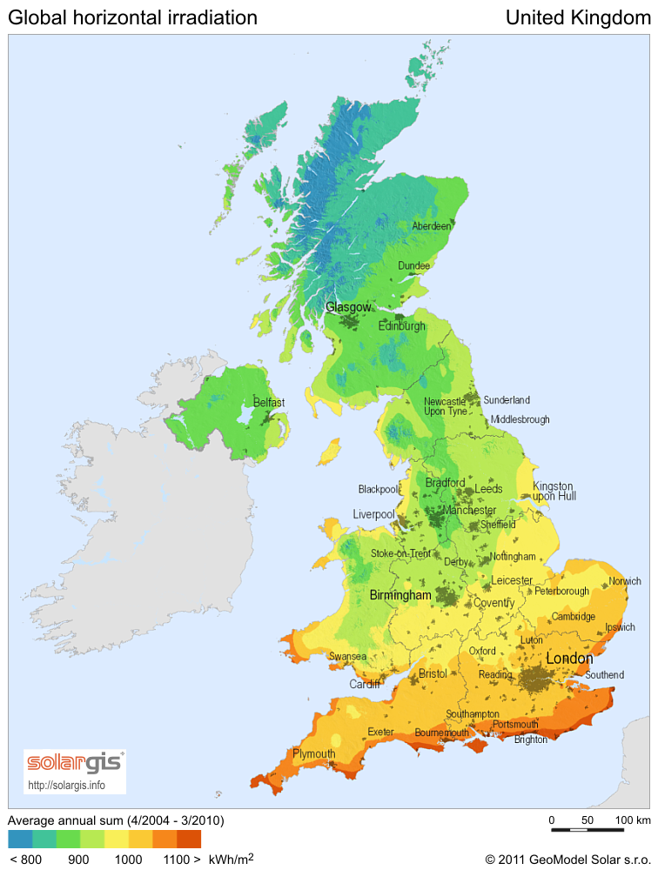
Figure 2: United Kingdom Solar Potential Map

Originally, the orangery was designed to run on a water boiler system that was primarily heated using coal. This system could be replaced with two outdoor central boilers that depending on the model type could run on either wooden pellets or corn fuel. Generally, central boilers are considered thermostatic meaning that they can act as a heating system or air conditioning system. Since both wood pellets and corn fuel are considered to be a type of fossil fuel, but rather a renewable resource, as they burn to produce heat no increase will be seen in the levels of carbon dioxide (Central Boilers 2013). But implementing the central boilers would simply decrease the individual carbon dioxide emissions at the Dalkeith estate.
Aside from providing a suitable environment to grow plants, the cellar holds two stone cisterns, which are containers used to collect water (Seen in figure 3). Although the potential projects mentioned above could provide a sustainable way to produce energy to heat the orangery, there was one that would have been included if it had not already been implemented within the cellar of the orangery (Johnstone 1988). They were designed to act like an artificial reservoir by collecting condensation from alternating sources, in addition to rooftop and surface drainage. Despite the fact that the grounds of Dalkeith became home to the orangery in 1832, the sustainable method of two stone cisterns, which were used by Burn and way beyond that of the time period. If the system were to be slightly modernized, it would not only be able to be used for the irrigation processes at Dalkeith, but also provide heating and ventilation in the orangery. However, this method would not only be providing a sustainable method of heating, but a decrease in runoff, or the flow of excess rainwater when the soil reaches its holding capacity. In addition to a decrease in runoff, there will also be a noticeable savings in water annually (CONTECH 2013). Therefore, this could promote the concept of water management to not only the students at Dalkeith but in turn the community as well.
Figure 3: Original heating and water arrangements of the Dalkeith Orangery

Furthering the sustainable approaches of restoration, a wide variety of composting methods could be implemented as well. Depending on the methods of restoration, composting may or may not be directly effective in heating methods for the orangery; however, they would indirectly supply nutrient rich fertilizer for the plants who would find home within not only the orangery but the remainder of the grounds. However, according to Melissa Deller there is compostable waste produced from the food services at Dalkeith, but she was unable to comment on how much was produced. Based on this information, the estate has potential to benefit from many sustainable renovations of infrastructure. The fertilizer could also support the community/campus garden that I have proposed above. By collecting and harvesting the heat produced during thermal composting there would be a potentially significant energy supply to the orangery. This would be more feasible during the summer than during the winter, because maximum heat is produced during the summer. The second type of composting is vermicomposting, which utilizes redworms to turn decomposing kitchen waste into a usable mixture that can be added to soil. Vermicomposting requires a ratio of carbon to nitrogen by weight of 30 to 1, as the carbon is supplied through such material as leaves, newspaper clippings, and grass clippings (SWANA 2002). As a half-pound of worms require a half pound of food every three days, which supports the nitrogen element of vermicomposting through kitchen waste (Green Calgary 2013). In order to improve the quality of products produced by vermicomposting and decrease the amount of composting time, there should be an element of pre-thermal composting (Nair et. al. 2005).
Overall, the major advantages to vermicomposting would be the creation of solid fertilizer and worm tea, commonly known as leachate (Chatterjee et. al. 2013). This cannot only be diluted into a liquid fertilizer filled with nutrients for plants and used within the grounds of Dalkeith in the gardens. Wisconsin in Scotland could follow the footsteps of the University of California, Santa Barbara and sell the leachate to the surrounding community. If the vermicomposting units were held inside the orangery, they could continue composting year round. But as far as the thermal composting, depending on the strength of the unit there would be a great benefit from its heat production during the summer months. However, because of the lowering temperatures during the winter there would have to be another alternative energy source to take the place of the thermal composting.
Similarly to composting, anaerobic digestion uses minerals found within manure to convert the stored energy to biogas. The biogas produced can be harvested and used as fuel or electricity, whereas the waste heat from the combustion can provide heating to the orangery or hot water to other areas of the Dalkeith grounds. Most biogas is comprised of 65 percent methane, which has the ability to yield 650 Btu per cubic foot (MREC 2006). A potential advantage as well as disadvantage would be that anaerobic digestion usually functions at an average temperature between 30°C and 60°C (86°F to 140°F), but is dependent on the area’s temperature. Energy conversions from anaerobic digestion can occur in higher temperatures, but the higher the temperature is, the less stable the process becomes (Van Lier et al 2001). Based on the past average summer and winter temperatures, shown in figures 4 and 5, the process has potential to have adequate results.
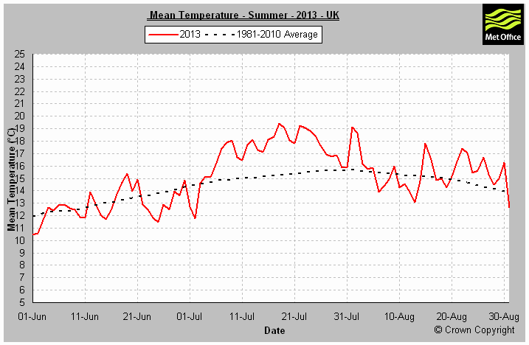

Figure 4: Average Temperature in the United Kingdom during the summer of 2013
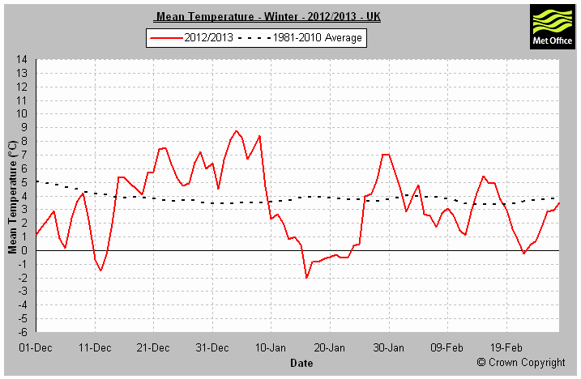

Figure 5: Average Temperature in the United Kingdom during the winter of 2012/13

Geothermal is a sustainable infrastructure that uses the earth’s inner ground temperatures to heat or cool the orangery depending on the season. This type of proposed infrastructure would be the most reliable out of all the systems to heat the orangery in winter. By using the grounds warm temperature, the orangery would be warm enough to seed proposed plants for the growing season during the summer. This wouldn’t be as feasible in maintaining the historic nature of the orangery, because intensive infrastructure is involved in constructing the geothermal system. But there is a cellar already in place that the geothermal system could potential be placed in, which would be better than digging open surface ground.
Conclusively, even though these proposed changes would be considered sustainable development and therefore slightly modernize the Dalkeith Orangery, it would still maintain and restore much of the original orangery as possible. Scottish building permits allow for the renovation of historic buildings with a proper proposal. With implementation of any of these proposed sustainable initiatives, there would be a creation of a sustainable culture on the Dalkeith grounds as well as in the community. As with any sustainable development method, there is always room for growth, but this could be the start in setting an example for other estates in the region to follow.

References
The National Energy Foundation: "Improving the use of energy in buildings". "Active Roofs - information from NEF and EurActive Roofer." Accessed November 9, 2013. http://www.nef.org.uk/greencompany/active-roof.htm.
Andersson, Eva, Simon Harvey, and Thore Berntsson. "Energy efficient upgrading of biofuel integrated with a pulp mill." Energy 31 (2006): 1384-1394. Accessed November 7, 2013. doi:10.1016/j.energy.2005.05.020.
B, Lier V., A. Tilche, B. K. Ahring, H. Macarie, R. Moletta, M. Dohanyos, L. W. Pol, P. N. Lens, and W. Verstraete. "New perspectives in anaerobic digestion." Water Science and Technology 43 (2001): 1-18.
Bucklin, Ray A. "Cisterns To Collect Non-Potable Water For Domestic Use." 1-4. Accessed November 16, 2013.
Central Boiler - Outdoor Wood Furnace for Home Heating. "Central Boiler - Outdoor Wood Furnaces." Accessed December 7, 2013. http://www.centralboiler.com/faq.html.
Chatterjee, Nirmalya, Markus Flury, Curtis Hinman, and Craig G. Cogger. "Chemical and Physical Characteristics of Compost Leachates." (2013): Accessed November 7, 2013.
Chuanshan, Dai. "Thermal analysis of indirect geothermal district heating systems." Geothermics 26, no. 3 (1997): 351-364. Accessed December 4, 2013. doi:10.1016/S0375-6505(96)00047-8.
Chynoweth, David P., John M. Owens, and Robert Legrand. "Renewable methane from anaerobic digestion of biomass." Renewable Energy 22 (2001): 1-8.
Deller, Melissa . Interview by author. Personal interview. Whitewater, WI, November 3, 2013.
Demirbas, Ayhan. "Biofuels sources, biofuel policy, biofuel economy and global biofuel projections." Energy Conversion and Management 49 (2008): 2106-2116. Accessed November 7, 2013. doi:10.1016/j.enconman.2008.02.020.
Department of Energy. "Solar." Accessed November 8, 2013. http://energy.gov/eere/renewables/solar.
Diver, Steve. "COMPOST HEATED GREENHOUSES." (2001): 1-5.
First Solar, Inc. - Investor Relations. "First Solar to Acquire TetraSun to Expand Addressable Market Opportunity (NASDAQ:FSLR)." Accessed November 7, 2013. http://investor.firstsolar.com/releasedetail.cfm?releaseid=755337.
Florida Rainwater Harvesting Initiative. "Rainwater Harvesting with Cisterns for Landscape Irrigation." (2009): Accessed November 10, 2013.
Fulford, Bruce. "THE COMPOSTING GREENHOUSE AT NEW ALCHEMY INSTITUTE: A REPORT ON TWO YEARS OF OPERATION AND MONITORING." no. 3 (1986): 1-24. Accessed November 7, 2013.
Gallert, C., and J. Winter. "Mesophilic and thermophilic anaerobic digestion of source-sorted organic wastes: effect of ammonia on glucose degradation and methane production." Applied Microbiology and Biotechnology 48 (1997): 405-410.
Green Building Elements. "Green Building Elements | From brick and mortar shops to city planning, we cover sustainable trends in construction, renovation, and more." Accessed November 7, 2013. http://greenbuildingelements.com/2013/10/22/cleaner-greener-cities-integrated-transparent-solar-cells/.
Green Calgary. "Composting | Resources." Accessed November 10, 2013. http://www.greencalgary.org/resources/composting/.
GSHPA | Ground Source Heat Pump Association is the focal point of the ground source heat pump industry | Renewable Heat | Renewable Cooling. Accessed December 7, 2013. http://www.gshp.org.uk/documents/ce82-domesticgroundsourceheatpumps.pdf.
Historic Scotland - the official website. Accessed December 7, 2013. http://www.historic-scotland.gov.uk/grants-building-repair-advisory-standards.pdf.
Home (England) - Energy Saving Trust England. "Thermal stores / Choosing a renewable technology / Generating energy / Home (England) - Energy Saving Trust England." Accessed November 17, 2013. http://www.energysavingtrust.org.uk/Generating-energy/Choosing-a-renewable-technology/Thermal-stores#1.
Irvine, G., E. R. Lamont, and B. Antizar-Ladislao. "Energy from Waste: Reuse of Compost Heat as a Source of Renewable Energy." International Journal of Chemical Engineering 2010 (2010): 1-10. Accessed November 6, 2013. doi:10.1155/2010/627930.
Johnstone, Andrew. "William Burn's Conservatory At Dalkeith Park." 4-21. Accessed October 31, 2013.
Jones, Matthew P., and William F. Hunt. "Rainwater Harvesting: Guidance for Homeowners." Accessed November 14, 2013.
Kirkhope, Jo . Interview by author. Email interview. Whitewater, WI & Scotland, December 2, 2013.
Manson, Cameron . Interview by author. Email interview. Whitewater, WI & Scotland, October 30, 2013.
Mason, Alan . Interview by author. Email interview. Whitewater,WI & Dalkeith, Scotland, October 30, 2013.
McIntosh, Charles. The Book of the Garden. Edinburgh and London: W. Blackwood, 1853.
McWilliam, Colin. The Buildings of Scotland: Lothian Except Edinburgh. Yale University Press, 1978.
Midwest Rural Energy Council. "MREC - Anaerobic Digestion and Bio-Gas." Accessed November 7, 2013. http://www.mrec.org/anaerobicdigestion.html.
Nair, Jaya, Vanja Sekiozoic, and Martin Anda. "Effect of pre-composting on vermicomposting of kitchen waste." Bioresource Technology 97 (2006): 2091?2095. Accessed November 6, 2013. doi:10.1016/j.biortech.2005.09.020.
Phetteplace, Gary. "Geothermal Heat Pumps." JOURNAL OF ENERGY ENGINEERING (2007): 32-38. Accessed December 7, 2013. doi:10.1061/ASCE0733-94022007133:132.
Powell, Crispin . Interview by author. Email interview. Whitewater, WI & Scotland, November 19, 2013.
Richardson, Albert E. Monumental Classic Architecture in Great Britain and Ireland, 2nd ed. London: Batsford, 1914.
Srinivas, M, and S. Jayaraj. "Energy and exergy analysis of a two pass photovoltaic ? thermal (PV/T) air heater." INTERNATIONAL JOURNAL OF ENERGY AND ENVIRONMENT 4, no. 3 (2013): 467-480. Accessed November 10, 2013.
Weather and climate change - Met Office. "Summer 2013- Met Office." Accessed December 9, 2013. http://www.metoffice.gov.uk/climate/uk/summaries/2013/summer.
Energy Information, Data, and other Resources | OpenEI. "United Kingdom: Energy Resources | Open Energy Information." Accessed December 8, 2013. http://en.openei.org/wiki/United_Kingdom.
AS Recycling | Reducing consumption, Reusing new materials. "Worm Tea Sales | AS Recycling." Accessed December 9, 2013. http://recycling.as.ucsb.edu/composting/worm-castings-and-tea-sales/.
Wang, Wanyue, and Xian Zhang. "Application Study on Heat Pump and Floor Radiant Heating in Geothermal Heating." (2010): Accessed December 6, 2013. doi:10.1109/APPEEC.2010.5448268.
Watters, Patty. Interview by author. Email interview. Whitewater, WI & Scotland, October 31, 2013.
Weather and climate change - Met Office. "Winter 2012/13- Met Office." Accessed December 9, 2013. http://www.metoffice.gov.uk/climate/uk/summaries/2013/winter.

